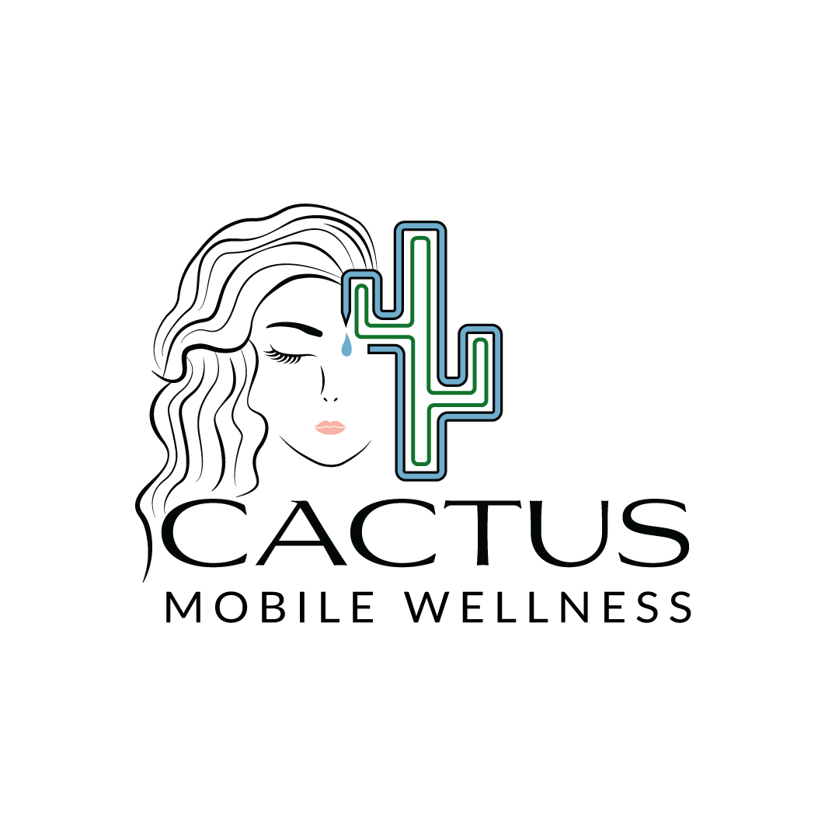

Botox/ Dysport Consent Form
BOTOX ® Cosmetic Botulinum Toxin Type A
Jeuveau PrabotulinumtoxinA-xvfs injection
Dysport® (abobotulinumtoxinA)

To the patient: Being fully informed about your condition and treatment will help you make the decision whether or not to undergo BOTOX/JEUVEAU/DYSPORT® Cosmetic treatment. This disclosure is not meant to alarm you; it is simply an effort to better inform you so that you may give or withhold your consent for this treatment.
I have requested that Cactus Mobile Wellness and it’s licensed provider attempt to improve my facial lines with BOTOX/JEUVEAU/DYSPORT® Cosmetic. This is the Allergan Inc. trademark for Botulinum Toxin Type A. These injections have been used for more than a decade to improve spasm of the muscles around the eye, to correct double vision due to muscle imbalance as well as numerous other neurological uses. BOTOX/JEUVEAU/DYSPORT® Cosmetic is now approved by the FDA to improve the appearance of the vertical lines between the brows. A few tiny injections of BOTOX/JEUVEAU/DYSPORT® Cosmetic relax overactive muscles and soften those vertical lines. Injections in other areas to improve appearance of facial lines have been reported in the literature, but the FDA has not approved those uses. The results of BOTOX/JEUVEAU/DYSPORT® Cosmetic are often dramatic, although the practice of medicine is not an exact science, and no guarantees can be or have been made concerning expected results.

_______ Initials The BOTOX/JEUVEAU/DYSPORT® Cosmetic solution is injected with a tiny needle into the muscle; you should see the benefits develop over the next two to seven days. A decreased appearance of frowning or creasing of other lines may be the result of this treatment. As with any injections, slight pain will likely accompany injections with BOTOX/JEUVEAU/DYSPORT® Cosmetic.

_______ Initials The most common side effects are headache, respiratory infection, flu syndrome, temporary eyelid droop, and nausea. Eyelid drooping may lead to dry eyes and eye drops may be required to be instilled into the eyes until the problem resolves. This resolution may take weeks to months. Double vision may occur after BOTOX/JEUVEAU/DYSPORT® Cosmetic injections but is very rare. Infection and allergic reaction are also rare side effects of BOTOX/JEUVEAU/DYSPORT® Cosmetic injections. Additionally, slight temporary bruising may occur at the injection site. There is the possibility additional risk factors may be discovered. BOTOX/JEUVEAU/DYSPORT® Cosmetic should not be used if there is an infection at the injection site. While effects beyond the local area being injected are extremely unlikely, they are not impossible. If I experience difficulty swallowing, talking, or breathing, or have slurred speech or muscle weakness I will seek emergency medical care immediately. I have been advised of the risks involved in such treatment, the expected benefits of such treatment, and alternative treatments, including no treatment at all.

_______ Initials I understand that I am having BOTOX/JEUVEAU/DYSPORT® Cosmetic injections for cosmetic purposes only. These injections are not being used to treat headaches, spasticity, eye disorders, or any other medical conditions. No suggestion of benefit of BOTOX/JEUVEAU/DYSPORT® Cosmetic injections for any medical conditions has been made by CLOVR Life Spa Gilbert providers or staff.

_______ Initials Alternative forms of management include; not treating the skin wrinkles by any means. Improvement of skin wrinkles may be accomplished by other treatments or alternative types of surgery such as a blepharoplasty, face or brow lift when indicated. Other forms of eyelid surgery may be needed should you have intrinsic disorders affecting the function of the eyelid such as drooping eyelids from muscle problems (eyelid ptosis) or looseness between the eyelid and eye (ectropion). Minor skin wrinkling may be improved through chemical skin-peels, lasers, injection of filling material, or other skin treatments. Risks and potential complications are associated with alternative forms of medical or surgical treatment.

_______ Initials I understand that the results are temporary, and several sessions may be needed for optimal results. The duration of effect generally lasts for approximately three to four months. Continuing treatments are necessary to maintain the effect of BOTOX/JEUVEAU/DYSPORT® Cosmetic over time. No guarantee has been made as to the outcome of my being treated with BOTOX/JEUVEAU/DYSPORT® Cosmetic, and I understand that the results may not be satisfactory to me.

_______ Initials Animal reproduction studies have not been performed to determine if BOTOX/JEUVEAU/DYSPORT® Cosmetic could produce fetal harm. It is not known if BOTOX/JEUVEAU/DYSPORT® Cosmetic can be excreted in human milk. It is not recommended that pregnant women or nursing mothers receive BOTOX/JEUVEAU/DYSPORT® Cosmetic treatments. I certify that I am not pregnant or nursing.

_______ Initials The effect of BOTOX/JEUVEAU/DYSPORT® Cosmetic may be potentiated by aminoglycoside antibiotics or other drugs known to interfere with neuromuscular transmission. I certify that I am not taking any such medication.

_______ Initials Patients with peripheral motor neuropathic disorders (amyotrophic lateral sclerosis, myasthenia gravis, motor neuropathies) may be at greater risk of clinically significant side effects from BOTOX/JEUVEAU/DYSPORT® Cosmetic. I certify that I have no known peripheral motor neuropathic disorders.

_______ Initials I consent to the photographing of the procedure(s) to be performed, including appropriate portions of my face, for medical, scientific, or educational purposes.
I agree that this constitutes full disclosure, and that it supersedes any previous verbal or written disclosures. I certify that I have read, and fully understand the above paragraphs, and that I have had sufficient opportunity for discussion and to ask questions. I consent to this BOTOX/JEUVEAU/DYSPORT® Cosmetic treatment today and for all subsequent treatments.

Signature | Date

